Town of Keene Regular Board Meeting

December 13th, 2022 7:00 P.M. Keene Valley Library
MTG Res. #332-341
Board Members Present: JoePete Wilson, Supervisor, Robert Biesemeyer, Deputy Supervisor, Christopher Daly, David Deyo, & Teresa Cheetham-Palen, Council Members
Board Members Absent: (none)
Town Counsel Present: Bryan Liam Kennelly, Esq
Town Officials Present: Reginald Whitney, Highway Superintendent, Savana Li, Water Superintendent
Members of the Public Present: Jerry Smith, Donna Reed Austin, Peter Slocum, Jeannie Cross
Meeting Called to Order at 7:00 by Joe Pete Wilson
Approve minutes:
RESOLUTION APPROVING TOWN BOARD MINUTES RESOLUTION NO.: 332, 2022
INTRODUCED BY: Mr. Deyo WHO MOVED FOR ITS ADOPTION
SECONDED BY: Mr. Daly RESOLVED, that the Bi-Monthly Town
Board minutes from November 29th, 2022 are accepted and approved. Duly adopted this 13th day of December 2022 by the following vote:
AYES: Supervisor Wilson, Mr. Biesemeyer, Mr. Daly, Mr. Deyo, and
Ms. Cheetham-Palen
NAYS: (none)
Privilege of the Floor: Jane Haugh has asked to speak but is running late
Old Business:
•Covid updates-none
'Water #1:
Mr. Wilson said waiting until 2023 to do our bond, Just a heads up WD #1 will be in the red to end the year.
'Water #2:
Mr. Wilson stated we had talked about having Hannah and Rob from Community Rescores to meet with board members to present about the Bonding process, about the impact of not getting the Weia grant, I want to know if after we get through our Organizational Meeting and get going into January can I schedule a meeting with them?
Mr. Deyo said sure, as long as we can get a few of us together we can ask questions and then circle back around to the members that cannot make.
Mr. Wilson ok I will get a few dates and see what works best.
Mr. Daly asked if we should ask Claude to be there and Mr. Wilson said no this is not about technical things this is more about the impact of not getting the grant and the scope of the project, what we can afford.
"Mr. Wilson then wanted to announce that Savana Lia passed her Water Licensing Test, Congratulations! l!!!
'Cemetery Rules Draft:
Mr. Wilson welcomed those that came on behalf of the Cemetery Committee and introduced Mr. Peter Slocum.
Mr. Slocum stated they started about a year and half ago on the expansion. They considered many things.
Please see Attachment labeled #1 that goes over his presentation.
Mr. Slocum stated that today they are looking for our approval of these regulations.
Mr. Deyo said this is a good common sense approach.
Mr. Biesmeye ask is there a reason why segregated .
Mr. Slocum said the Green cemetery approach will be attractive to more people we believe, if it is allowed to grow wild. Mr. Daly questioned the plot ownership #5
Mr. Deyo said we would continue the way we have which is case by case.
Mr. Deyo said I feel we can Adopt this draft and work with it for the "New Norton's", Mr. Wilson stated we have a motion , Ms. Cheetham-Palen seconded, all in favor Supervisor Wilson, Mr. Biesmeyer, Mr. Daly, Mr. Deyo, and Ms. Cheetham-Palne.
Nayes: None
• •Mr. Wilson wanted to let board members know that we got our annual report back from Agriculture and Markets and we passed with flying colors. This is the Dog Control Officers Inspection Report.
•Library Combined Operations MOU
Mr. Wilson said with the New Year starting the Keene Valley Library asked if we reviewed the new MOU, Mr. Wilson asked if we could make a motion to make a resolution to adopt.
RESOLUTION TO ADOPT THE UPDATED MOU
RESOLUTION NO.: 333,2022
INTRODUCE BY: Ms. Cheetham-Palen WHO MOVED FOR ITS
ADOPTION
SECONDED BY: Mr. Daly
RESOLVED, that the Town Board approves the updated MOU.
Discussion: Mr. Daly asked if we budged for this ?
Mr. Wilson said we have it in the 2023 budget.
Mr. Deyo said he remembered us talking about doing this.
Duly adopted this 13th day of December 2022 by the following vote:
AYES: Supervisor Wilson, Mr. Biesemeyer, Ms. Cheetham-Palen, Mr. Daly,
Mr. Deyo
NAYS: (none)
Ms. Palen asked about the Keene Library and where we were at with re-construction, from there Mr. Biesemeyer and Mr. Smith started a discussion over what it needed and Mr. Smith may take a look at it and possibly take it on.
•2023 Meeting Schedule and Location
Mr. Wilson said we need to schedule our End of Year meeting which we moved our Bi-Monthly last year and did both together , I propose we do our Bi-Monthly and End of Year to Thursday the 22nd a.m. at the Town Hall.
RESOLUTION TO MOVE THE BI-MONTHLY MEETING AND SCHEDULE THE END
OF YEAR MEETING
RESOLUTION NO.: 334, 2022
INTRODUCED BY: Ms. Cheetham-Palen WHO MOVED FOR ITS ADOPTION SECONDED BY: Mr.Deyo RESOLVED, that the BI-Monthly Meeting scheduled for the 27th move to the 22nd of December and to have the End of Year Meeting at this time as well, 10:00a.m. at the Town Hall
Duly adopted this 13th day of December,2022 by the following vote:
AYES: Supervisor Wilson, Mr. Biesemeyer, Mr. Daly, Mr. Deyo, Ms. Cheetham-Palen
NAYS: (none)
RESOLUTION TO SCHEDULE THE ORGINAZTIONAL MEETING
FOR JANURARY 4TH, 2023

RESOLUTION NO: 335,2022
INTRODUCED BY : Mr. Deyo WHO MOVED FOR ITS ADOPTION
SECONDED BY: Mr. Daly RESOLVED, that the Town Board set the
Organizational Meeting for January 4th , 2023 at 10:00 a.m. at the Town Hall
Duly adopted this 13th day of December, 2022 by the following vote:
Ayes: Supervisor Wilson, Mr. Beisemeyer, Mr. Daly, Mr. Deyo, Ms.
Cheetham-Palen Nays: None
•Leash Law:
Mr. Wilson asked to schedule an Informational Meeting to get publics input, set Informational Meeting on January 10th at 6:00 p.m. prior to Regular monthly meeting at Town Hall.
New Business:
•Appoint Tony Goodwin as Town Historian
Mr. Wilson stated that the Historical Society found a Town Historian and we need a motion to appoint Tony Goodwin as the new Historian.
RESOLUTION APPOINTING TONY GOODWIN AS THE
TOWN HISTORIAN
RESOLUTION NO.: 336, 2022
INTRODUCED BY: Ms. Cheetham-Palen WHO MOVED FOR ITS ADOPTION SECONDED BY: Mr. RESOLVED, that Tony Goodwin be appointed the Town Historian.
Duly adopted this 13th day of December, 2022 by the following vote:
AYES: Supervisor Wilson, Mr. Biesemeyer, Mr. Daly, Mr. Deyo, Ms. Cheetham-Palen
NAYS: (none)
Executive Session:
RESOLUTION FOR THE TOWN BOARD TO ENTER INTO EXECUTIVE SESSION FOR LEGAL ADVICE RESOLUTION NO.: 337,2022
INTRODUCED BY: Supervisor Wilson WHO MOVED FOR ITS ADOPTION
SECONDED BY: Mr.Daly RESOLVED, that the Town Board went into Executive Session at 7:40 p.m.
Duly adopted this 13th day of December, 2022, by the following vote:
AYES: Supervisor Wilson, Mr.Biesemeyer, Mr.Daly, Mr.Deyo, Ms.
Cheetham-Palen NAYS: none
RESOLUTION TO RETURN FROM EXECUTIVE SESSION
RESOLUTION NO.: 338,2022
INTRODUCED BY: Mr. Deyo WHO MOVED FOR ITS ADOPTION SECONDED BY: Ms. Cheetham-Palen RESOLVED, that the Town Board is returning from Executive Session at 7:59 p.m. and entering into Regular Session with no decisions being made.
Duly adopted this 13th day of December, 2022, by the following votes:
AYES: Supervisor Wilson, Mr. Biesemeyer,Mr. Dayl, Mr. Deyo, Ms. Cheetham-Palen, NAYS: none
Budget Resolutions: (none)
Supervisor's Report : August & September 2022

RESOLUTION TO ACCEPT THE AUGUST AND SEPTEMBER SUPERVISOR
REPORTS
RESOLUTION NO.: 339, 2022
INTRODUCED BY: Mr. Deyo WHO MOVED FOR ITS ADOPTION
SECONDED BY: Ms. Cheetham-Palen RESOLVED that the Town Board accepts the August and September 2022 Supervisor's Financial Statement as presented, and placed on file with the Town Clerk.
Discussion: Ms. Cheetham-Palen talked with Kathy, she is ok with the discrepancy, and they will get it where it needs to be.
Duly adopted this 13th day of December, 2022 by the following vote:
AYES: Supervisor Wilson, Mr. Biesemeyer, Mr. Daly, Mr. Deyo, Ms. Cheetham-Palen
NAYS: None
Privilege of the Floor:
Keene Diversity Advisory Committee:
Supervisor Wilson welcomed Jane Haugh.
Ms. Hough apologized for being late. She explained that the board has the proposal in front of them. The desire of the committed was to have the Board take this on and ask DEC to create equitable access for all New Yorkers.
Please see Attachment labeled #2
Mr. Deyo believes the State is trying to make access for all.
Mr. Daly said these are a great set of recommendations but I have one concern, a campsite at the bottom of Spruce Hill, which seems intense for that area. I am wondering the thought process for a potential campsite for that area.
Ms. Haugh thought maybe because there was already access there. Maybe this is not the best place, it was just a suggestion.
Mr. Deyo said this is a good start, a leaping off point.
Mr. Biesemeyer said maybe if we are thinking a campground maybe look at Marcy Field. We could maybe benefit as a Town.
Supervisor Wilson said looking at this and hearing the concerns I think the spirt of this, the Diversity Community is looking for us to throw our weight behind this getting DEC to start looking at this. Maybe one change in the second to the last paragraph, would that disrupt to much of this.
Ms. Haugh, no not at all.
After much discussion, the Board is going to work on the proposal.
Mr. Wilson asked Ms. Haugh to send him the proposal in a form so they can work on it, he only had a pdf.
Ms. Haugh stated she would do that.
Audit Bills:
RESOLUTION TO AUDIT THE VOUCHERS #22-987 through
#22-1030
RESOLUTION NO.: 340,2022
INTRODUCED BY: Mr. Biesemeyer who moved for its adoption SECONDED BY: Mr. Deyo
RESOLVED, that the Town Board approves the following bills for payment, including those that were prepaid.
Multi-Fund Vouchers numbered 22-987 through 22-1030, totaling $73,495.19 as follows:
General Fund Bills $59,631.08 Highway Fund Bills $8,945.14
Water District Bills $783.17
Water District #2 Bills $4,135.80
Duly adopted this 13th day of December, 2022, by the following vote:
AYES: Supervisor Wilson, Mr. Biesemeyer, Mr. Daly, Mr. Deyo, Ms. Cheetham-Palen NAYS: none
Adjourn:
RESOLUTION TO ADJOURN
RESOLUTION NO.: 341 ,2022
INTRODUCED BY: Mr. Deyo who moved for its adoption SECONDED BY: Mr. Daly
RESOLVED, that the Town Board of the Town of Keene has completed all business and hereby adjourns the Regular Meeting at 8:19 p.m. Duly adopted this 13th day of December, 2022, by the following vote:
AYES: Supervisor Wilson, Mr. Biesemeyer, Mr. Daly, Mr. Deyo, Ms.
Cheetham-Palen
NAYS: none
Anna Whitney, Town Clerk, Town of Keene
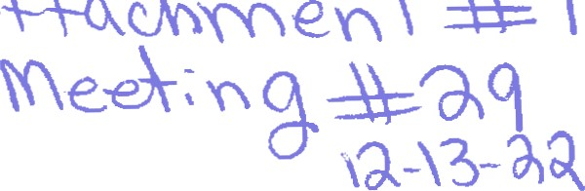
PHYSICAL PLAN FOR THE "NEW NORTON."
The plan for the "New Norbn," an Il-acre expansion, is to offer three burial opäons to Keene
--traditional casket/vault burial
-smaller for cremation urns
—natural burials with no embalming, or traditional caskets.
The attached map shows the three planned sections. There are different rules and regulations for each of the sections, as debiled in the draft proposal for board approval.
For instance, the natural seåion will be allowed to grow wild, except for an annual mowing to keep down invasives and bee growth. The fraditional burial sedion will be mowed the same way the current Norton cemetery is groomed.
The new cemetery will also be developed in to save money for the Town and to gauge public in the different sections and types of burial. Cremaäon has been growing fast in popularity during the 2F Century, and Natural burials are also growing in popularity in communities where they are offered.
The plan calls for initial surveying and layout of 150 in both the natural and aernaöon secüons, and 100 in the traditional section. The town can amend this plan as town make their choices.

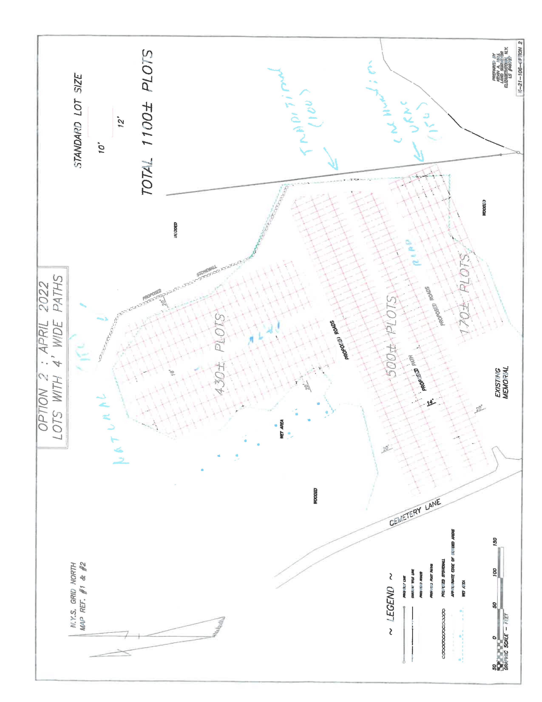

Rules and Regulations of Norton Cemetery Town of Keene, New York
GENERAL
- All lots in the Norton Cemetery are sold in accordance with the provisions of the laws of the State of New York and shall not be used for any other purposes than as a burial place for dead human beings. See attached fee schedule for current charges, which are set by the Town Board and subject to change.
- No interment shall be allowed without permission being first obtained from the Town Clerk in coordination with the cemetery sexton. At the time of applying for permission, the following information must be furnished --Name of deceased.
--Age of deceased- including date of birth if known.
--Place of birth of the deceased, if known.
--Date and place of death.
--Time and date of interment.
--Names of parent(s) or legal guardian of deceased minors.
-Cause of death.
- Lot owners are prohibited from reselling lots, except back to the Town of
Keene. Except as provided for in Section 1513 © of the Not-for-Profit Corporation Law, no lot owner may transfer his or her lot without the permission of the Town of Keene.
- Interments in a lot are restricted to those entitled to burial therein according to the terms of section 1512 of the Not-for-Profit Corporation Law. Permission for burial of those not entitled to burial according to the said section, must be filed with the Town Clerk by the owners.
- Plot Ownership is restricted to property owners, residents and persons who have a provable relationship with the Town of Keene.
- The full purchase price and endowment care fee must be paid before a deed can be issued or burial allowed on the lot.
- No lights are allowed to be placed in the cemetery and all flowers placed on gravesites must be biodegradable. No pesticides are allowed.
- The Town of Keene reserves the right to remove, after due notice to the lot owner, any embellishment on the lot, effigy or inscription which in the opinion of the majority of the trustees, is unsightly or dangerous.
- The Town of Keene reserves the right to remove all flowers, wreaths, or other decorations from lots as soon as they become unsightly or dangerous. any shrub or tree deemed dangerous to the public and destructive to the property, upon due notice to the lot owner. Shrubs, bushes or small trees may not be planted. Annual and perennial plants are permitted if they are placed at the head of a grave and within 1 8 inches of the grave marker. They must be natural to the Adirondack region.
- Above ground headstones, crypts, mausoleums, and monuments are allowed only in the traditional-casket burial section. Corner posts are required for all graves in all sections and will be purchased with the burial plot. The posts will be installed by the Cemetery Sexton.
I I. No crypt or mausoleum shall be built above ground without permission of the Town board.
- Only one monument (not to include footstones) shall be allowed on a lot and it shall be set in accordance with the general plan of the cemetery and shall conform with said plan in size and material.
- The base of all monuments shall be finished true and level so as to fit on foundations without wedging or sprawls. Bases must be built according to specifications provided and be approved by cemetery sexton. No monument will be allowed to be delivered to the cemetery until the foundation is installed and approved.
- Heavy trucking or other vehicular traffic shall be refused entrance to the cemetery when, in the opinion of the cemetery sexton, damage to roads and driveways might result.
- Disinterment will be allowed provided there is compliance with all the provisions of Section 1510 (e) of the Not-for-Profit Corporation Law and with notification to the Town of Keene.
- Graves will not be opened when frost or weather conditions warrant such refusal on the determination of the cemetery sexton. Bodies received for interment during this time will be placed in the vault until weather permits burial. They must be stored in a sealed casket, and will be charged a vault holding fee of $60/month payable to the Town of Keene.
- All bodies left in the vault after four months will be removed and interred. If not entitled to burial in a family plot, they will be interred in a single grave. The expense of such interment shall be borne by those who caused the body to be placed in the vault. The town shall make an effort to notify family members. 18. Cremated remains will not be permitted to be scattered in any part of the cemetery.
- A cemetery advisory committee will be formed to make recommendations to the Town Board.
- These rules and regulations may be amended by the Keene Town Board.
TRADITIONAL CASKET BURIALS SECTION
- This is the only section of the cemetery where permanent, above ground grave markings are allowed. Please refer to the rules below regarding installation. All monuments are restricted in size to dimensions that will not cover more than 20% of the plot's surface area.
- Concrete vaults or concrete grave liners will be required for all interments. 3. The internment of cremated remains in this cemetery section will be permitted only in appropriate rigid and covered receptacles such as bronze, plastic or concrete. All human remains must be in a vault. Biodegradable containers alone are not sufficient in this section of the cemetery
NATURAL BURIAL SECTION
l. The natural section of Norton Cemetery is reserved for burials that do not use a vault of any kind and for bodies that have not been embalmed.
  - Burial containers are limited to those made from nontoxic, natural materials, without the use of metal nails or screws. Among the permitted materials: untreated wood, wool, fiber, cloth, cardboard, bamboo, wicker, hemp and papier Mache.
  - Shrouded bodies not in a container shall be completely wrapped and supported on a solid, untreated board for lowering. Plywood and particle board are not acceptable.
  - Families may participate in the internment, including lowering a body into the grave, or may ask the sexton to provide that service. The sexton will dig, or supervise the digging, of all graves.
  - Cars are not permitted inside this section,
  - Grave markers shall be flat, flush with the grade level, no larger than 24"x12" and be of natural stone. No polished stones are permitted.
  - All graves are dug to 3 ¹/2 feet. They will be mounded, mulched, and allowed to return to a natural state.
  - Indigenous perennials and annual plants are permitted on and near the grave.
  - The area will be mowed annually, after the growing season, to aid in control of invasive plants and ticks.
CREMATED REMAINS SECTION
- Only cremated remains shall be interred in this section.
- No markers above grade level shall be permitted.
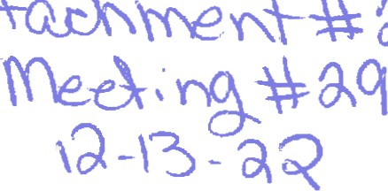
Keene Diversity Advisory Committee
Proposed December 2022
The Town of Keene is widely known throughout the northeast as a major outdoor recreation destination. Hiking, camping, climbing, skiing, birding, and other activities are abundant in this tiny mountain hamlet of just over a thousand people.
The State of New York owns seventy-two percent of the land in the Town of Keene, and provides dozens of access opportunities to enjoy that land. Unfortunately there are several communities of people who don't share that access.
Accessibility to outdoor spaces, and the many health and emotional benefits that come from that access has historically excluded people with disabilites, the aging community, and families with small children.
The Town of Keene would like the State of New York to lead the way in removing some of those barriers and create equitable access for all New Yorkers, and for those who visit our state. We can think of no better place to do that than right here in Keene.
We would like the State of New York to develop trails that are compliant with the Americans With Disabilities Act (ADA), water access, and campsites to serve those communities. We think the trail to the base of Roaring brook Falls offers a wondeól opportunity to start this necessary work. With a little effort, the existing trail there can be made ADA compliant, and plenty of opportunity exists to create one or more ADA compliant campsites along that trail.
There has long been a small parking area and a dirt road at Chapel Pond. With a little work, an ADA compliant walkway to the pond from the parking area can be made, and the dirt road can be converted to a canoe launch site, with parking reserved for water users.
The open area at the bottom of NYS Route 9N, south of the hamlet of Keene can be used to create —r ADA compliant access to an area with a unique geologic formation, a kame, or glacial mound.
We urge the NYS Department of Environmental Conservation to prioritize creating space for communities that have been excluded for too long. We look forward to working with the state of New York to further these opportunities .
Thank you,
KDAC

